CHAPTER 9: Sedimentary, igneous and metamorphic rocks
Worksheet 9.3

Sedimentary rocks
Student: Class:

Rock face
1. Photograph A shows a rock face in a road cutting. Photographs B, C and D show three rocks.
A | 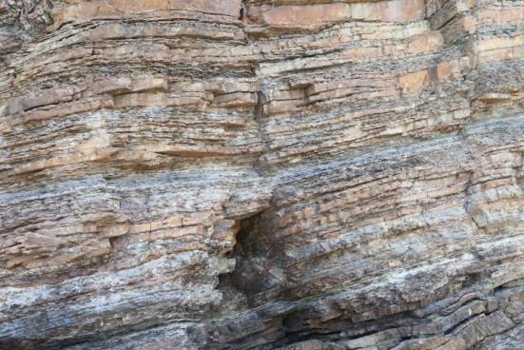 | B | 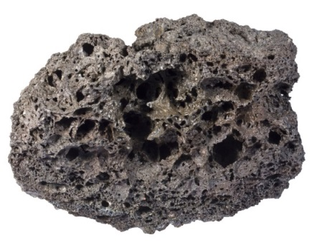
C | 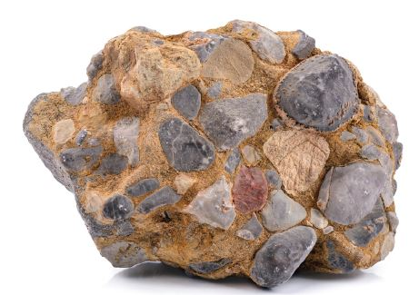 | D | 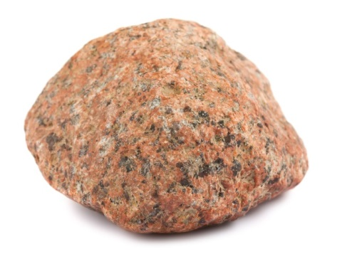
(a) Explain how a student studying photograph A would decide that the rocks shown were probably sedimentary.
(b) Closer examination of the rocks in the road cutting confirmed they were sedimentary. Identify which rock sample (B, C or D) would most likely be found in this road cutting. Explain your answer.

Photo A: Sujin Jetkasettakorn / 123RF.com
Photo B: Siim Sepp / 123RF.com
Photo C: sonsam / Shutterstock.com
Photo D: Andrey Eremin / 123RF.com

Types of sedimentary rocks
2. (a) The following table provides information on the types of sedimentary rocks. Complete the table by naming the sediments that form each rock. |  |  |  |  | (b) Construct a pie chart of the types of sedimentary rocks in the space below.  
 | Sediment | Rock type | %
 |  | Shale | 67
 |  | Sandstone | 19
 |  | Limestone | 9
 |  | Other sedimentary rocks | 5

